Nasima Perfume Inc First Payment:
Bank Account End: 276
Duration: Dec 6, 2016, to July, 7, 2018
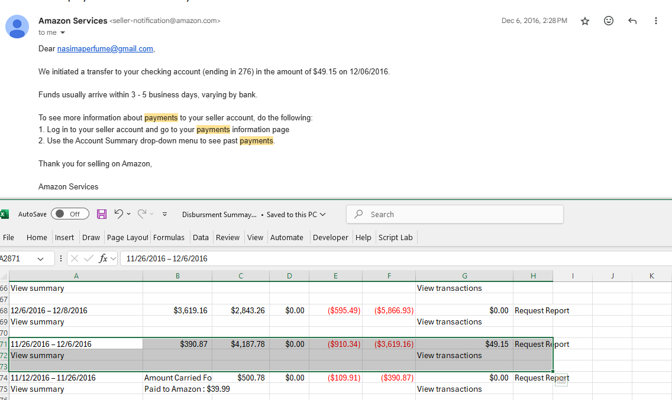

Bank account changed 276 to 738,
Bank account end: 738
Duration: July 7, 2018 to February 12, 2019
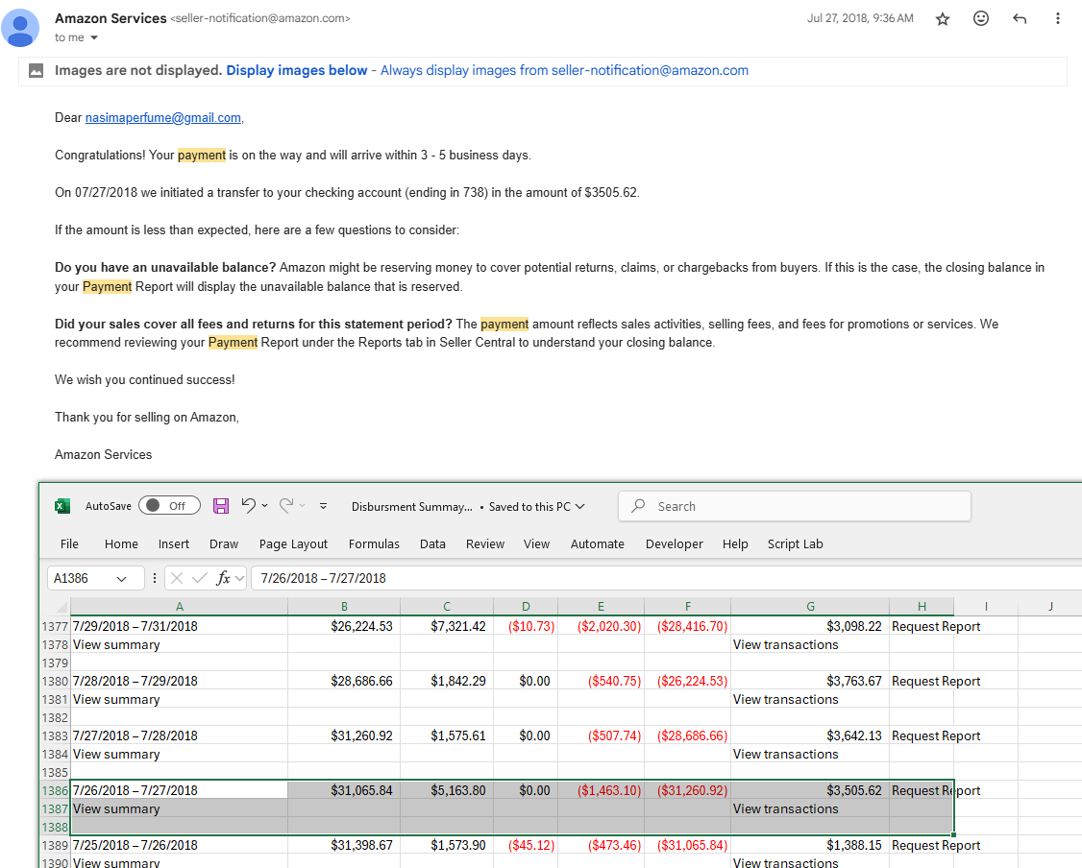

Bank account changed 738 to 22.
Bank account end: 221
Duration: Feb 12, 2019 to March 14, 2020
